📝 Notes
Apr 22, 2026

[Check-in] Conserva Irrigation - V4 Company
Invited karina.reginato@conservairrigation.com Marcos Luciano Peretto - V4 Company (Peretto) Fhelipe Aranha Andrade Lucas Procópio
Attachments [Check-in] Conserva Irrigation - V4 Company
Meeting records Transcript Recording

Summary
Meeting discussions focused on optimizing traffic benchmarking, local service strategies, and Google Ads performance integration.
Performance Benchmarking and Strategy
Traffic performance requires forecasting using Google Ads and specific data management. Integration with workspace storage analysis helps identify key performance benchmarks.
Artificial Intelligence and Optimization
Utilizing long-tail keywords and artificial intelligence supports search engine optimization. Teams must prioritize landing page structure to improve service rankings.
Local Service Stabilization
Focus shifts to stabilization and real-time local service requirements. Performance Max serves as the primary mechanism for managing ongoing Google Ads campaigns.

Rate this Summary: Helpful or Not Helpful

Next steps
- [Karina Reginato] Check Traffic: Review dashboard metrics for traffic graph data.
- [Marcos Luciano] Prepare Tally: Provide a tally related to Google Ads performance benchmarks.

Details
Did the screenshots in this section make your notes better or worse?
- Traffic and Performance Benchmarking: Marcos Luciano and Karina Reginato discussed performance related to traffic, including benchmarks using Google Ads. There was confirmation of a need to forecast performance. Marcos Luciano also mentioned specific timelines, referencing February and March, and concepts like credit scores, Home Garden Homeowners, and the use of Google Ads for identification processes, managed by Silver King data manager (00:00:00).
- Google Ads Strategies and Video Integration: The conversation proceeded to discuss specific Google Ads formats, including maximum TrueView for video. Marcos Luciano mentioned integrating search keys for maximization of ads. The discussion also included the potential impact of certain elements, with both speakers acknowledging the need for consideration (00:18:20).
- Integration of Data and Service Analysis: The speakers confirmed the necessity of integrating data with Google Ads, discussing how to drive this integration. There was mention of using Workspace for storage analysis, which was affirmed by Marcos Luciano. The team also discussed quick wins and benchmarks within this framework, citing Victorich (00:28:12).
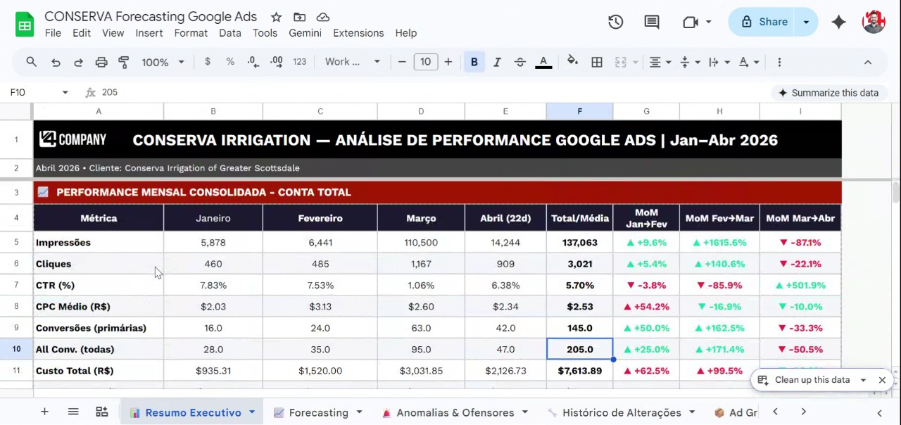
- Local Service and Ranking Impact: Marcos Luciano elaborated on strategies concerning Google Ads and local service impact. They mentioned providing a tally for performance tracking. The discussion concluded with a focus on local service and response ranking for local businesses (00:42:34).
- Discussion on Artificial Intelligence and Keywords: Marcos Luciano and Karina Reginato discussed the concept of artificial intelligence, which Karina Reginato mentioned by saying "intelligence artificial". Marcos Luciano emphasized using long-tail keywords and discussed concepts related to search engine optimization, including imagining landing pages and focusing on "Service Mind" (00:54:49).
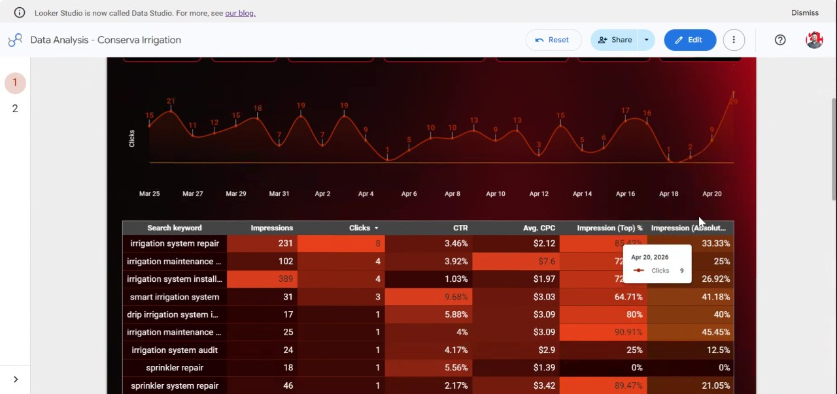
- Focus on Real-Time and Local Service: The conversation shifted to implementing strategies in real-time and focusing on local services as significant factors. Marcos Luciano specified that "local service" is a minimum requirement, and Karina Reginato confirmed the term "Local service" (00:54:49).
- Reference to Startup and Stabilization: Marcos Luciano mentioned that the current phase does not relate to a spring starting page startup, but rather to stabilization. They also discussed strategies related to Asia, landing pages, Google pages, and YouTube (00:54:49).
- Performance Max and Google Ads: Marcos Luciano brought up Performance Max as a concept, leading to further discussion. The conversation concluded with Marcos Luciano emphasizing "Local service" again and mentioning Google ads (00:54:49).

You should review Gemini's notes to make sure they're accurate. Get tips and learn how Gemini takes notes
How is the quality of these specific notes? Take a short survey to let us know your feedback, including how helpful the notes were for your needs.

📖 Transcript
Apr 22, 2026

[Check-in] Conserva Irrigation - V4 Company - Transcript

00:00:00
Marcos Luciano: Perfect.
Karina Reginato: I'll go see.
Marcos Luciano: Dash. for traffic. Okay. graph. % Foreign speech. Foreign speech. Foreign speech.
Karina Reginato: Mhm.
Marcos Luciano: Topch.
Karina Reginato: Close
Marcos Luciano: Uh,
Karina Reginato: my
Marcos Luciano: formul
Karina Reginato: video. Mhm.
Marcos Luciano: Okay. Yes. Fore for example. Benchmark.
Karina Reginato: It's
Marcos Luciano: Google Ads. as performances. to the bank. No, no, no, no. Okay. foreign.
Karina Reginato: No, no.
Marcos Luciano: Okay. has
Karina Reginato: See?
Marcos Luciano: forecast. Yeah. back to
Karina Reginato: Mhm.
Marcos Luciano: mainch. Home Garden Homeowners
Karina Reginato: What?
Marcos Luciano: knowch. Fore! Foreign! Foreign! forology.
Karina Reginato: Mhm.
Marcos Luciano: Okay. February, March. forgive. credit score. Max, Google ads. Soch. foridentific Forecess Google ads. Silver King data manager.

00:18:20
Marcos Luciano: Okay. Fore! Foreign! Foreign! performance.
Karina Reginato: Mhm.
Marcos Luciano: Max for True View.
Karina Reginato: video.
Marcos Luciano: Okay.
Karina Reginato: Video
Marcos Luciano: Uh which monster Print you get the
Karina Reginato: Fore!
Marcos Luciano: miss. Uh for Foreign speech. Foreign speech. Foreign
Karina Reginato: Mhm.
Marcos Luciano: speech. Foreign
Karina Reginato: Mhm.
Marcos Luciano: speech. Foreign speech. Foreign speech. for Yeah.
Karina Reginato: Fernando. on this.
Marcos Luciano: impact.
Karina Reginato: Mhm.
Marcos Luciano: Forever.
Karina Reginato: Mhm.
Marcos Luciano: Okay.
Karina Reginato: Mhm.
Marcos Luciano: For example, let's Okay. foreign. Search the key.
Karina Reginato: Mhm.
Marcos Luciano: Yeah.
Karina Reginato: Damn
Marcos Luciano: for
Karina Reginato: it.
Marcos Luciano: maximization. for ache. ads. Yeah.
Karina Reginato: Perfect.
Marcos Luciano: Search Independ. Fore!
Karina Reginato: Mhm.
Marcos Luciano: Foreign! Foreign! For example, Fore!

00:28:12
Marcos Luciano: Foreign! Foreign! Yeah, Fore!
Karina Reginato: We're gonna
Marcos Luciano: Foreign! Foreign!
Karina Reginato: stop.
Marcos Luciano: temperature. Yes. formalized.
Karina Reginato: See?
Marcos Luciano: He seems to for
Karina Reginato: Mhm. Mhm.
Marcos Luciano: Okay. All right.
Karina Reginato: Mhm.
Marcos Luciano: For example, So drive it. for my integr. to Google Ads.
Karina Reginato: Oops.
Marcos Luciano: Okay. for
Karina Reginato: Mhm.
Marcos Luciano: example. for service. for etc. Hey,
Karina Reginato: Okay.
Marcos Luciano: Google.
Karina Reginato: Mhm.
Marcos Luciano: for
Karina Reginato: Mhm.
Marcos Luciano: hatch. Fore
Karina Reginato: Mhm.
Marcos Luciano: speech.
Karina Reginato: Excuse me.
Marcos Luciano: for example. Fore! Foreign! Foreign! for storage analysis.
Karina Reginato: Just squeeze.
Marcos Luciano: Yeah. Workspace. Okay. So, Don't see quad. No.
Karina Reginato: Mhm.
Marcos Luciano: Victorich. Quick wings benchmark.
Karina Reginato: Mhm.

00:42:34
Marcos Luciano: For example,
Karina Reginato: Mhm. Mhm.
Marcos Luciano: for Google Ads.
Karina Reginato: Nothing. Okay.
Marcos Luciano: for I give him a tally.
Karina Reginato: Yes. Mhm.
Marcos Luciano: Okay,
Karina Reginato: Mhm.
Marcos Luciano: sir.
Karina Reginato: Okay. Yeah, I hear
Marcos Luciano: Yeah.
Karina Reginato: something.
Marcos Luciano: Speech. Speech.
Karina Reginato: That's not
Marcos Luciano: Fore local service. Impact local service. Foreign speech. Foreign speech. Foreign speech.
Karina Reginato: There you go.
Marcos Luciano: for movement. response ranking. Okay. For example, for Local service. local business. Yeah. Yes.
Karina Reginato: Nice meeting
Marcos Luciano: True
Karina Reginato: you.
Marcos Luciano: Okay.
Karina Reginato: Mhm. Mhm.
Marcos Luciano: foreign. Okay.
Karina Reginato: Okay. Sorry,
Marcos Luciano: It's
Karina Reginato: Mota.
Marcos Luciano: just okay. I got
Karina Reginato: Okay. See
Marcos Luciano: one online.
Karina Reginato: for
Marcos Luciano: See my
Karina Reginato: services.

00:54:49
Marcos Luciano: speaker.
Karina Reginato: The companion was
Marcos Luciano: Okay. Okay. foreign. Okay. foreign. Okay.
Karina Reginato: I will say intelligence artificial
Marcos Luciano: Mhm. Fore! Foreign! Foreign! Long as keywords long tail. forchech. Imagine. Okay. Fore page.
Karina Reginato: Mhm.
Marcos Luciano: More
Karina Reginato: Mhm.
Marcos Luciano: Service Mindchech.
Karina Reginato: Okay. Okay.
Marcos Luciano: Forement
Karina Reginato: Thank you.
Marcos Luciano: for example
Karina Reginato: Okay.
Marcos Luciano: Foreign
Karina Reginato: Mhm.
Marcos Luciano: in life. Real time. Fore speech. forch.
Karina Reginato: Mhm.
Marcos Luciano: was significant. Fore local service.
Karina Reginato: Local service.
Marcos Luciano: minimum. Okay. Local service. This
Karina Reginato: Mhm.
Marcos Luciano: don't mean him. Spring Starting page startup. Happy group.
Karina Reginato: f*** off.
Marcos Luciano: Okay. Alert.
Karina Reginato: What's happening?
Marcos Luciano: for
Karina Reginato: Focus.
Marcos Luciano: stabiliz. etc.,
Karina Reginato: I can do this.
Marcos Luciano: etc. for a keych. Asia. Yeah. foreign. landing page Google page.
Karina Reginato: Mhm.
Marcos Luciano: for YouTube.
Karina Reginato: Mhm.
Marcos Luciano: Okay. Okay. Yeah. YouTube. for Javi.
Karina Reginato: Uhhuh.
Marcos Luciano: Performance Max. forchech. honest. Foreign speech. Foreign speech. Foreign speech. foreign. Okay. No. Okay.
Karina Reginato: Mhm.
Marcos Luciano: Don't be etc. foreign. Okay. Local Local service force. local service. Yeah.
Karina Reginato: See? Okay. Say good.
Marcos Luciano: local service. Okay. Google
Karina Reginato: Okay.
Marcos Luciano: ads foreign.
Karina Reginato: Okay.
Marcos Luciano: Okay.
Karina Reginato: Mhm.
Marcos Luciano: Okay. Okay.
Karina Reginato: Okay.
Marcos Luciano: Ah, minimum.
Karina Reginato: Okay. Okay. Tell

Transcription ended after 01:21:12

This editable transcript was computer generated and might contain errors. People can also change the text after it was created.

